
Department of Electrical and Computer Engineering
North South University

Directed Research

Instance-Aware Object Removal and Background Reconstruction Using Hybrid Inpainting with Statistical Evaluation

Md. Minhajul Islam ID# 2211022042
Azmain Iqtidar Arnob ID# 2211786042
Aqib Ahmed ID# 2211335042
Atikul Islam Nahid ID# 2211978042

Faculty Advisor:
Dr. Jilan Samiuddin
Assistant Professor
Department of Electrical & Computer Engineering
North South University
Spring, 2026

APPROVAL
Md. Minhajul Islam (ID # 2211022042), Azmain Iqtidar Arnob (ID # 2211786042), Aqib Ahmed (ID # 2211335042) and Atikul Islam Nahid (ID # 2211978042) from Electrical and Computer Engineering Department of North South University, have worked on the Directed Research Project titled “Instance-Aware Object Removal and Background Reconstruction Using Hybrid Inpainting with Statistical Evaluation” under the supervision of Dr. Jilan Samiuddin partial fulfillment of the requirement for the degree of Bachelors of Science in Engineering and has been accepted as satisfactory.

Supervisor’s Signature

…………………………………….
Dr. Jilan Samiuddin
Assistant Professor
Department of Electrical and Computer Engineering
North South University
Dhaka, Bangladesh.

Chairman’s Signature

…………………………………….
Dr. Mohammad Abdul Matin
Professor
Department of Electrical and Computer Engineering
North South University
Dhaka, Bangladesh.

DECLARATION

This is to declare that this project/directed research is our original work. No part of this work has been submitted elsewhere partially or fully for the award of any other degree or diploma. All project related information will remain confidential and shall not be disclosed without the formal consent of the project supervisor. Relevant previous works presented in this report have been properly acknowledged and cited. The plagiarism policy, as stated by the supervisor, has been maintained.

Students’ names & Signatures

1. Md. Minhajul Islam

_ _ _ _ _ _ _ _ _ _ _ _ _ _ _ _ _
2. Azmain Iqtidar Arnob

_ _ _ _ _ _ _ _ _ _ _ _ _ _ _ _ _
3. Aqib Ahmed

_ _ _ _ _ _ _ _ _ _ _ _ _ _ _ _ _
4. Atikul Islam Nahid

_ _ _ _ _ _ _ _ _ _ _ _ _ _ _ _ _

ACKNOWLEDGEMENTS

The authors would like to express their heartfelt gratitude towards their project and research supervisor, Dr. Jilan Samiuddin, Assistant Professor, Department of Electrical and Computer Engineering, North South University, Bangladesh, for his invaluable support, precise guidance and advice pertaining to the experiments, research and theoretical studies carried out during the course of the current project and also in the preparation of the current report.
Furthermore, the authors would like to thank the Department of Electrical and Computer Engineering, North South University, Bangladesh for facilitating the research. The authors would also like to thank their loved ones for their countless sacrifices and continual support.

ABSTRACT
Instance-Aware Object Removal and Background Reconstruction Using Hybrid Inpainting with Statistical Evaluation

Realistic object removal from complex multi-person scenes remains a challenging problem due to difficulties in accurate segmentation and high-quality background reconstruction. Traditional inpainting methods often produce blurred or texture-inconsistent outputs.Diffusion-based approaches struggle when large regions of the image are removed, especially in real-world scenarios involving multiple interacting individuals. We proposes a multi-stage instance-aware object removal framework that integrates detection, segmentation, and hybrid inpainting techniques. The proposed method first detects person instances using a deep learning-based object detector, followed by mask generation and refinement to ensure accurate object boundaries. We applied a hybrid inpainting strategy , where a global inpainting model reconstructs the overall scene structure, and a diffusion-based model performs local refinement to enhance fine details and visual realism. To address large-mask reconstruction challenges, context-aware masking and iterative refinement are incorporated as additional improvements. The proposed framework is evaluated on a subset of real-world images containing multiple persons, where it achieves an average PSNR of approximately 18.17, SSIM of 0.713, and OUT-SSIM of 0.774.This is indicating strong reconstruction quality and preservation of non-masked regions. The proposed approach produces more visually coherent outputs compared to baseline methods, particularly in scenes with moderate mask sizes. However, An average residual detection count of 6.96 from residual detection analysis shows that complete removal remains challenging and highlighting limitations in fully suppressing object presence. Overall, our work demonstrates that combining global and local inpainting techniques in a structured pipeline improves reconstruction quality in complex scenes while providing a more comprehensive evaluation strategy that considers both visual quality and residual object presence.
A hybrid inpainting strategy is then applied, where a global inpainting model reconstructs the overall scene structure, and a diffusion-based model performs local refinement to enhance fine details and visual realism. Additional improvements such as context-aware masking and iterative refinement are incorporated to address large-mask reconstruction challenges. The proposed framework is evaluated on a subset of real-world images containing multiple persons, where it achieves an average PSNR of approximately 18.17, SSIM of 0.713, and OUT-SSIM of 0.774, indicating strong reconstruction quality and preservation of non-masked regions. Compared to baseline methods, the proposed approach produces more visually coherent outputs, particularly in scenes with moderate mask sizes. However, residual detection analysis shows that complete removal remains challenging, with an average residual detection count of 6.96, highlighting limitations in fully suppressing object presence. Overall, this work demonstrates that combining global and local inpainting techniques in a structured pipeline improves reconstruction quality in complex scenes while providing a more comprehensive evaluation strategy that considers both visual quality and residual object presence.

TABLE OF CONTENTS
APPROVAL ii
DECLARATION iii
ACKNOWLEDGEMENTS iv
ABSTRACT v
TABLE OF CONTENTS vii
LIST OF FIGURES ix
LIST OF TABLES x
Chapter 1 Introduction 1
1.1 Background and Motivation 1
1.2 Purpose and Goal of the Project 2
1.3 Organization of the Report 3
Chapter 2 Research Literature Review 4
2.1 Existing Research and Limitations 4
Chapter 3 Methodology 6
3.1 System Design 6
3.2 Hardware and/or Software Components 10
3.3 Software Implementation 11
Chapter 4 Experiment, Result, Analysis and Discussion 13
4.1 Experimental Setup 13
4.2 Baseline Comparison 13
4.3 Progressive Removal Analysis (Week 4 Study) 15
4.4 Multi-Method Comparison and Trade-off Analysis(week 5) 17
4.5 Stage-wise Development of the Final Pipeline 19
4.6 Final Proposed Method Evaluation 21
4.7 Discussion 24
Chapter 5 Conclusions 25
5.1 Summary 25
5.2 Limitations 26
5.3 Future Improvement 26
References 28

LIST OF FIGURES
Figure 1: Goal Illustration 2
Figure 2 : Mask refinement process 7
Figure 3 : Global–local reconstruction strategy 7
Figure 4: Residual-aware evaluation 8
Figure 5 : Proposed system architecture 9
Figure 6: Baseline comparison visual grid 15
Figure 7: Metric comparison between Method A & Method B 16
Figure 8: Per-image win-rate comparison between Method A & Method B 17
Figure 9: Per-image performance comparison of Methods A–D 18
Figure 10: Trade-off analysis of reconstruction quality and object removal effectiveness under increasing scene complexity. 19
Figure 11: Stage-wise evolution of the proposed instance-aware object removal pipeline 21 Figure 12: Qualitative results of the final proposed pipeline 23

LIST OF TABLES
Table I: Software And Tools Used 11
Table II: Quantitative comparison of five pretrained inpainting baselines evaluated on the same image subset. 14
Table III: Quantitative comparison between single-shot removal and progressive instance-wise removal. 16
Table IV: Multi-method comparison showing the trade-off between reconstruction quality and residual object removal. 18
Table V: Final performance summary of the proposed Stage 2 V2 pipeline
on evaluated samples. 22

Chapter 1 Introduction

Background and Motivation
Digital image editing has become an important area of computer vision because modern applications often require automatic modification, restoration, and reconstruction of visual content. Among these tasks, object removal is one of the most challenging problems. The goal of object removal is not only to erase a selected object from an image, but also to reconstruct the missing background in such a way that the edited region becomes visually consistent with the surrounding scene. This task becomes significantly harder when the target objects are large, when multiple objects are present, or when the removed region contains complex textures, lighting variations, and structural information.
In real-world images, human subjects often occupy a large portion of the scene. Examples include group photographs, crowded public environments, and social events. Removing one or more persons from such images requires accurate object localization, precise mask generation, and realistic background reconstruction. Recent advances in object detection models such as YOLO have significantly improved real-time instance detection performance [1], while segmentation models such as the Segment Anything Model (SAM) have enabled highly accurate mask generation for arbitrary objects [2]. Despite these advancements, generating visually consistent background reconstruction after object removal remains a challenging problem.
Traditional inpainting methods, such as Telea and Navier–Stokes-based approaches, are computationally efficient and perform reasonably well for small missing regions, but they often fail to preserve texture consistency and semantic structure in large masked areas. Learning-based approaches such as LaMa have improved global image reconstruction by utilizing large receptive fields and advanced convolutional designs [3]. More recently, diffusion-based generative models, including Stable Diffusion and related methods, have demonstrated strong capability in generating realistic textures and semantic content [4], [5]. However, these models are highly sensitive to mask size and quality, and their performance degrades when large portions of the image are removed, often resulting in unrealistic or structurally inconsistent outputs.
This research is motivated by the limitations of existing methods in handling complex multi-person scenes. Instead of treating object removal as a single-step inpainting problem, this project proposes a structured, instance-aware pipeline that integrates detection, segmentation, mask refinement, and hybrid inpainting. By combining global reconstruction and local refinement, the proposed approach aims to improve visual consistency while addressing the large-mask failure problem observed in diffusion-based methods.

Purpose and Goal of the Project
The purpose of this project is to develop a robust and scalable framework for instance-aware object removal and high-fidelity background reconstruction in real-world images containing multiple persons showed in figure1. While modern detection and segmentation models, such as YOLO [1] and SAM [2], enable accurate identification and isolation of objects, reconstructing the background after object removal remains a complex task, particularly when large regions of the image are affected. Classical inpainting techniques are limited in handling large or semantically complex regions, while diffusion-based models, although capable of generating realistic textures, often struggle to maintain structural consistency when applied globally to large masks [4], [5]. These challenges highlight the need for a more structured and hybrid approach.
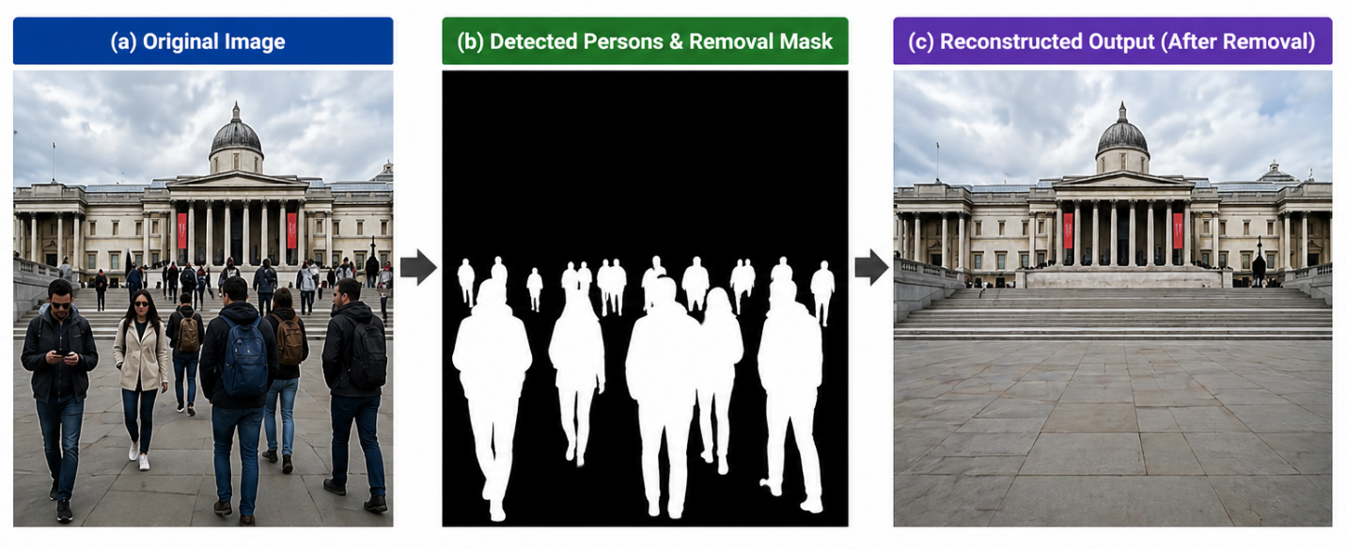
Figure 1: Goal Illustration
The primary goal of this research is to design a multi-stage object removal framework that integrates instance-level detection, mask refinement, and hybrid inpainting to improve reconstruction quality which is shown in figure1. The proposed method applies a global inpainting model, inspired by approaches such as LaMa [3], to reconstruct the overall structure of the image, followed by a diffusion-based local refinement stage to enhance fine details and perceptual realism. This combination of global and local processing is intended to leverage the strengths of both approaches while minimizing their individual limitations.
Another key objective of this work is to introduce a more comprehensive evaluation strategy. Conventional evaluation methods rely primarily on image similarity metrics such as PSNR and SSIM, which measure reconstruction accuracy but do not fully indicate whether the removed object is still perceptually or semantically present. To address this limitation, this research incorporates a residual detection-based evaluation approach, where a person detection model is applied to the reconstructed image to assess whether removed objects are still detectable. This provides a more realistic measure of object removal performance in practical scenarios.
The main contributions of this project can be summarized as follows. First, an instance-aware multi-stage object removal pipeline is proposed that integrates detection, segmentation, mask refinement, and hybrid inpainting within a unified framework. Second, a hybrid global–local inpainting strategy is introduced, combining the structural reconstruction capability of LaMa with the detail enhancement ability of diffusion-based models. Third, a residual detection-based evaluation method is incorporated to provide a more realistic assessment of object removal performance beyond traditional image similarity metrics.
The novelty of this work lies in the integration of these components into a structured pipeline designed specifically for complex multi-person scenes. Unlike conventional single-step approaches, the proposed method processes images through multiple coordinated stages, improving reconstruction quality while addressing the large-mask failure problem. Experimental results demonstrate that the proposed method achieves an average PSNR of approximately 18.17 and SSIM of 0.713 in the reconstructed regions, while maintaining strong preservation of non-masked areas with an OUT-SSIM of 0.774. At the same time, residual detection analysis reveals that complete object removal remains challenging in complex scenes, highlighting important limitations and motivating further research.

Organization of the Report
This report is organized into five chapters following the standard structure of a directed research report. Chapter 1 introduces the background, motivation, and objectives of the project, highlighting the challenges of object removal in multi-person scenes and the need for a hybrid instance-aware approach.
Chapter 2 presents a review of existing research related to object detection, instance segmentation, image inpainting, and diffusion-based image generation. It also discusses the limitations of current approaches, particularly in handling large masked regions and complex real-world scenarios.
Chapter 3 describes the proposed methodology in detail. It explains the system design, dataset preparation, detection and segmentation process, mask refinement techniques, hybrid inpainting strategy, and implementation details of the multi-stage pipeline.
Chapter 4 presents the experimental investigation, results, analysis, and discussion. It includes baseline comparison, progressive removal analysis, multi-method trade-off analysis, stage-wise pipeline development, final proposed method evaluation, and qualitative discussion of success and failure cases.
Finally, Chapter 5 concludes the report by summarizing the key findings of the project. It also discusses the limitations of the proposed framework and outlines possible directions for future improvement.

Chapter 2 Research Literature Review

2.1 Existing Research and Limitations
Object removal and image inpainting have been extensively studied in computer vision, with methods evolving from classical diffusion-based techniques to deep learning and modern generative models. This section reviews key research contributions in object detection, segmentation, and inpainting, along with their datasets, reported performance, and limitations in handling complex multi-person scenes.
Early image inpainting techniques were based on partial differential equations (PDEs). Bertalmio et al. [6] introduced a Navier–Stokes-based inpainting method that propagates image gradients into missing regions to maintain structural continuity. Similarly, Telea [7] proposed a fast marching-based method that improves computational efficiency while preserving local structures. These methods are typically evaluated on small synthetic masks and simple image datasets, where they produce visually acceptable results. However, they lack semantic understanding and fail when the missing region becomes large. As a result, although these methods can achieve relatively high structural similarity (SSIM values often above 0.70 for small masks), they produce blurred and unrealistic textures in complex scenarios involving large object removal.
The introduction of deep learning significantly improved inpainting performance. Pathak et al. [8] proposed Context Encoders, trained on large-scale datasets such as ImageNet, using an encoder–decoder architecture combined with adversarial loss. Their model demonstrated the ability to generate semantically meaningful content, achieving improved visual realism compared to classical methods. However, the generated outputs were often blurry, with perceptual quality limited by the model’s inability to capture fine details. Later, Yu et al. [9] introduced gated convolution-based inpainting, trained on datasets such as Places2 and CelebA-HQ, which improved handling of irregular masks. Their method achieved better SSIM (around 0.80 on benchmark datasets with moderate mask sizes) and improved structural consistency. Despite these improvements, CNN-based methods still struggled with large missing regions and complex scene reconstruction.
A significant advancement in inpainting was introduced by Suvorov et al. [3] through LaMa (Large Mask Inpainting), which uses Fourier convolutions to capture global context. LaMa was trained on the Places2 dataset and demonstrated strong performance across various benchmarks. In their experiments, LaMa achieved improved perceptual quality, with LPIPS scores reduced to approximately 0.10–0.15 on standard datasets and better structural consistency compared to previous CNN-based models. LaMa is particularly effective for large masks, as it leverages global context for reconstruction. However, despite its strong structural reconstruction capability, LaMa often produces overly smooth textures and lacks fine-grained semantic detail in complex regions.
Parallel to inpainting research, object detection and segmentation have also seen rapid development. The YOLO framework, introduced by Redmon et al. [1], demonstrated real-time object detection with competitive accuracy, achieving mean Average Precision (mAP) of around 63.4% on the PASCAL VOC dataset. More recent versions have significantly improved detection performance on large-scale datasets such as MS COCO. The Segment Anything Model (SAM) proposed by Kirillov et al. [2] represents a major advancement in segmentation, trained on billions of masks across diverse datasets. SAM demonstrates strong generalization ability and produces high-quality segmentation masks for a wide range of objects. However, while detection and segmentation models can accurately localize objects, they do not address the problem of reconstructing the background after object removal.
More recently, diffusion-based generative models have achieved state-of-the-art performance in image synthesis and inpainting. Rombach et al. [4] introduced Latent Diffusion Models, trained on large-scale datasets such as LAION-5B, achieving high-quality image generation with reduced computational complexity. Lugmayr et al. [5] proposed RePaint, a diffusion-based inpainting approach evaluated on datasets such as CelebA-HQ and ImageNet. Their method achieved strong perceptual quality, with LPIPS values around 0.03–0.05 for moderate mask sizes and improved realism compared to GAN-based approaches. However, diffusion-based methods have significant limitations. Their performance degrades when the masked region becomes large, often resulting in unrealistic or structurally inconsistent outputs. Additionally, these models are computationally expensive and sensitive to mask quality and prompt design.
Recent research has attempted to combine multiple techniques to improve inpainting performance. Hybrid approaches aim to integrate structural reconstruction with generative refinement, but most existing works do not fully integrate instance-level detection, mask refinement, and reconstruction into a unified pipeline. Furthermore, evaluation in many studies relies primarily on PSNR and SSIM, which measure pixel-level similarity but do not capture whether the removed object is still perceptually present. This limitation is critical in object removal tasks, where visual smoothness does not guarantee successful removal.
From the literature, several key limitations can be identified. Classical methods fail to reconstruct large and semantically complex regions. CNN-based approaches improve structure but lack fine detail generation. Diffusion-based models produce realistic textures but struggle with large masks and structural consistency. Detection and segmentation models do not address reconstruction. Additionally, most existing works lack comprehensive evaluation strategies that consider residual object presence.
These limitations motivate the proposed research, which introduces a multi-stage, instance-aware object removal framework that integrates detection, segmentation, mask refinement, hybrid inpainting, and residual-aware evaluation. By combining global reconstruction and local refinement, and by incorporating a more realistic evaluation strategy, the proposed approach aims to address the shortcomings of existing methods in complex multi-person scenes.

Chapter 3 Methodology

3.1 System Design
The proposed system is designed as a multi-stage instance-aware object removal and background reconstruction framework for real-world images containing multiple persons. The main objective of the system is not only to remove selected human instances from an image, but also to reconstruct the missing background in a visually coherent and structurally consistent manner. In conventional inpainting pipelines, an image and a binary mask are directly passed to an inpainting model, and the model attempts to fill the missing region in a single step. However, this approach becomes unreliable when the target region is large, when several persons overlap, or when the mask boundary is irregular. During the early experiments of this project, it was observed that single-shot removal often produced distorted textures, blurry regions, and incomplete object suppression, especially when the combined person mask occupied a large portion of the image. Therefore, the final proposed system was designed as a structured pipeline where detection, segmentation, mask processing, reconstruction, refinement, and evaluation are handled as separate but connected stages.
The complete system begins with a real-world input image selected from a multi-person subset of the COCO dataset. The images contain different levels of scene complexity, including group photographs, crowded environments, variable lighting, background clutter, and overlapping human subjects. Since the project focuses on instance-aware person removal, the first stage of the pipeline performs automatic person detection and segmentation using YOLOv8x-seg. The model identifies all visible person instances in the image and generates segmentation masks for the detected individuals. This stage replaces the need for manual mask drawing and allows the system to scale from single-image testing to batch-level evaluation. In the early stages of the project, SAM-based mask generation and click-guided segmentation were explored, but the final pipeline uses YOLOv8x-seg because it provides both detection and segmentation in a single automated framework.
After the person instances are detected, the generated masks are combined into a unified removal mask. This mask represents the regions that need to be removed and reconstructed. However, raw segmentation masks are not always directly suitable for inpainting. They may contain small holes, fragmented edges, rough boundaries, or incomplete coverage around body parts. If such masks are passed directly into an inpainting model, the final output may contain visible halos, remaining object boundaries, or unnatural transitions between the reconstructed and original regions. For this reason, mask refinement is a critical component of the proposed system which s shown in figure 2. The mask refinement stage applies morphological operations such as closing and opening to fill gaps and remove noise. Additional dilation is used to ensure that the full object boundary is covered, including small edge regions that may otherwise remain visible. Smoothing and feathering are then applied to soften the transition between the masked and unmasked areas.
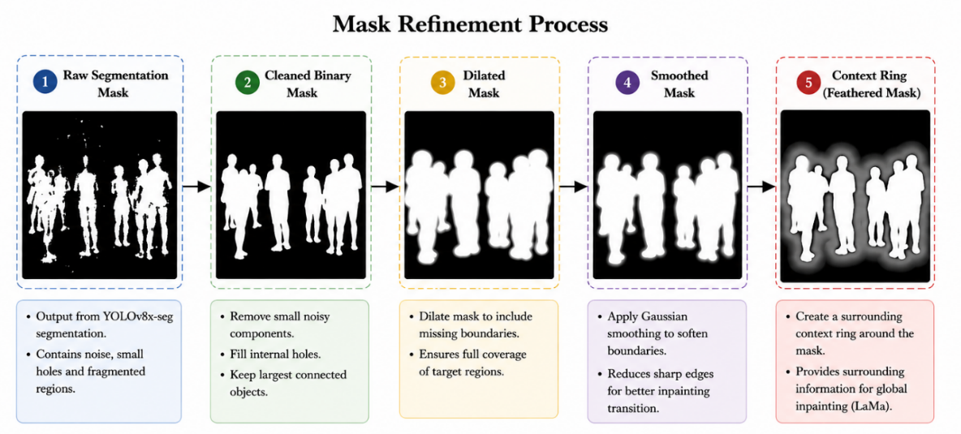
Figure 2: Mask refinement process

A context-aware mask representation is also used in the system. In addition to the main binary removal mask, a surrounding context region is generated around the object boundary. This context ring helps guide the reconstruction process by identifying the nearby image area that should influence the generated background. The use of contextual information is important because object removal does not depend only on the pixels inside the mask. The reconstructed region must be consistent with the surrounding texture, lighting, perspective, and scene structure. Therefore, the context ring provides a more informative spatial reference for later reconstruction and evaluation.
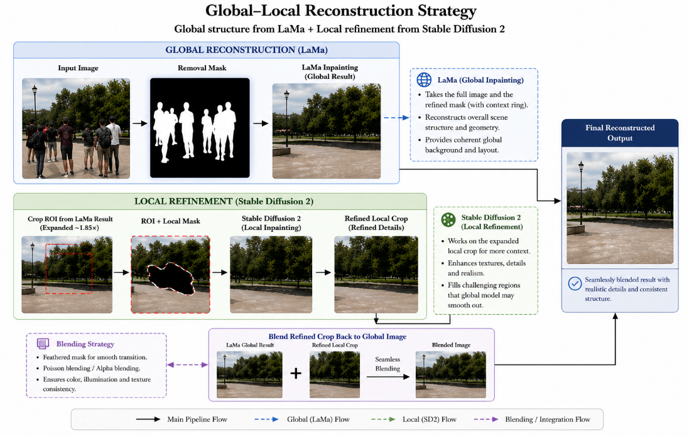
Figure 3: Global–local reconstruction strategy

The reconstruction stage of the system follows a hybrid global–local design showed in figure 3. The first reconstruction stage uses LaMa as a global inpainting model. LaMa is applied to the full image with the refined removal mask and is responsible for reconstructing the overall background structure. This stage is important because it preserves global layout and produces a complete reconstructed image efficiently. In many cases, LaMa provides stable background continuation and avoids the extreme hallucination sometimes observed in diffusion-only inpainting. However, LaMa may produce overly smooth textures or limited fine details in complex regions. Therefore, the system does not rely only on LaMa as the final output.
To improve perceptual realism, the second reconstruction stage applies diffusion-based local refinement using Stable Diffusion 2 inpainting. Instead of applying the diffusion model to the entire image, the system extracts a local crop around the removed region. This crop is expanded beyond the mask boundary to include surrounding contextual pixels, with an expansion ratio of approximately 1.85. The crop is resized to a target resolution of 512×512 and passed to the diffusion inpainting model. This local refinement strategy reduces the difficulty of the generation task because the diffusion model focuses only on the region that needs visual enhancement, rather than hallucinating the entire scene. The diffusion stage uses the LaMa output as the structural base and improves local texture, blending, and perceptual details. In the final implementation, the diffusion model was configured with 30 inference steps and a guidance scale of 7.5.
The proposed system includes a second-pass refinement step. After the initial reconstruction, YOLOv8x-seg is applied to the output to detect any remaining person-like regions. If persons are detected above a confidence threshold of 0.20, the local crop is re-inpainted with a slightly expanded mask. In the final evaluation, this second-pass step was triggered on all test samples, which is expected given that the multi-person images contain several individuals beyond the primary removal targets.
A major design decision in this research is the use of residual-aware evaluation . Most image inpainting systems are evaluated using metrics such as PSNR, SSIM, and LPIPS. These metrics are useful for measuring reconstruction quality, but they do not directly answer whether the target object has been removed. For example, an output image can have high structural similarity while still containing person-like residual shapes. To address this limitation, the proposed system applies YOLOv8x-seg again on the reconstructed image. The number of remaining detected persons and the maximum residual confidence are recorded as removal-effectiveness indicators. This makes the evaluation more meaningful for the specific task of object removal. It should be noted that the residual detection count reflects all persons visible in the reconstructed output, including persons who were present in the original scene but were not selected as removal targets. Figure 4 represents the residual aware evaluation flow.
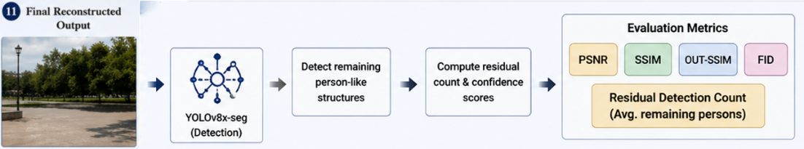
Figure 4: Residual-aware evaluation

The final system is therefore not a simple inpainting model, but a complete object removal framework. It includes dataset selection, automatic person detection, mask generation, mask refinement, context-aware processing, global background reconstruction, diffusion-based local enhancement, second-pass refinement, and residual detection-based evaluation. The proposed methodology can be summarized as follows: the input image is first analyzed to detect all person instances; the corresponding masks are refined to produce a clean removal region; the refined image-mask pair is passed through LaMa to reconstruct the global structure; the reconstructed region is then locally refined using Stable Diffusion 2; the final image is evaluated using both reconstruction metrics and residual detection metrics. Figure 5 demonstrates the whole system architecture at a glance.

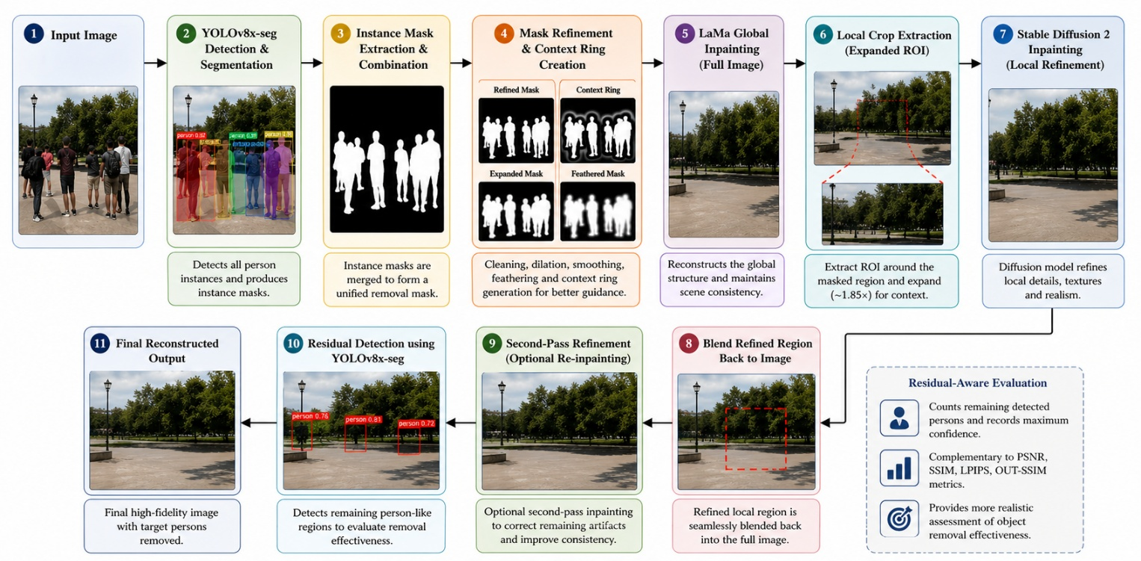
Figure 5: Proposed system architecture

3.2 Hardware and Software Components
The implementation of the proposed instance-aware object removal framework relies on a combination of modern deep learning models, image processing techniques, and GPU-accelerated computing environments. Since the system integrates multiple stages—including detection, segmentation, mask refinement, global reconstruction, local diffusion-based refinement, and evaluation—it requires both computational efficiency and model interoperability.
The primary dataset used in this research is a curated subset of the MS COCO dataset, which contains diverse real-world images with multiple human instances. From the original dataset, 200 images containing multiple persons were selected to reflect realistic scenarios such as group photos, crowded environments, and complex backgrounds. To ensure meaningful evaluation, a filtering process was applied based on mask area ratio, resulting in 104 valid samples used for the final experimental analysis. This filtering step was necessary to remove extremely small or excessively large masks that could bias reconstruction performance.
For object detection and segmentation, the system employs the YOLOv8x-seg model, which provides both bounding box detection and pixel-level segmentation in a unified architecture. The model is configured with a confidence threshold of 0.25 to ensure reliable detection of person instances. YOLOv8x-seg was selected due to its ability to handle multiple objects efficiently and its robustness in real-world conditions. Earlier experiments explored the use of SAM for mask generation, but YOLOv8x-seg was ultimately chosen because it enables fully automated large-scale processing without manual interaction.
Mask refinement is implemented using classical image processing techniques provided by OpenCV. These include morphological operations such as closing and opening to remove noise and fill gaps, dilation to expand the mask region, and Gaussian smoothing to soften boundaries. Additional feathering techniques are applied to create a smooth transition between masked and unmasked regions. A context ring is also generated around the mask boundary to provide additional spatial information for reconstruction models.
The global inpainting stage is performed using the LaMa model, which is known for its ability to reconstruct large missing regions using global context. LaMa was selected because of its efficiency and its strong performance in maintaining structural consistency across large masked areas. However, since LaMa tends to produce smoother textures, it is complemented by a diffusion-based refinement stage.
For local refinement, the system uses a Stable Diffusion 2 inpainting model implemented through the Hugging Face Diffusers library. The model operates on cropped regions around the masked area, allowing it to focus on fine details without affecting the entire image. The diffusion process is configured with 30 inference steps and a guidance scale of 7.5, which provides a balance between realism and stability.
Evaluation is performed using both reconstruction-based metrics and detection-based metrics. Standard image quality metrics such as PSNR, SSIM, and LPIPS are used to measure structural and perceptual similarity. Additionally, OUT-SSIM is used to evaluate how well the non-masked regions are preserved. To measure removal effectiveness, the YOLOv8x-seg model is applied again to detect any remaining person instances in the reconstructed images. This residual detection approach provides a more realistic evaluation of object removal performance.
The entire system is implemented using Python and relies on several key libraries, including PyTorch for deep learning, OpenCV for image processing, and Diffusers for diffusion-based inpainting. The experiments are conducted in a GPU-enabled environment, such as Google Colab or Kaggle, using NVIDIA GPUs (e.g., Tesla T4 or A100), which are necessary for handling large models and high-resolution images efficiently.

TABLE I. SOFTWARE AND TOOLS USED
Tool | Functions | Other similar Tools | Why selected this tool
YOLOv8x-seg | Object detection & segmentation | Mask R-CNN, Detectron2 | Fast, accurate, unified detection & segmentation
LaMa | Global image inpainting | DeepFill v2, EdgeConnect | Strong performance on large masks, efficient
Stable Diffusion 2 | Local refinement | DALL·E, Imagen | High-quality texture and semantic generation
PyTorch | Deep learning framework | TensorFlow | Flexibility and compatibility with models
OpenCV | Image processing | PIL, skimage | Efficient mask processing operations
Diffusers | Diffusion model integration | Custom implementations
  Easy integration of Stable Diffusion

3.3 Software Implementation
The implementation of the proposed system follows a structured multi-stage pipeline, where each stage is executed sequentially to ensure consistent processing and reproducibility. The system is designed to handle real-world images in a fully automated manner, allowing batch-level processing without manual intervention.
The process begins with dataset preparation, where the selected COCO images are loaded and paired with automatically generated segmentation masks. For each image, the YOLOv8x-seg model is applied to detect person instances and generate corresponding masks. These masks are combined into a unified removal mask, which represents all regions to be removed from the image. This automated mask generation stage enables the system to scale efficiently across large datasets.
The next stage involves mask refinement. The raw masks produced by the detection model are processed using morphological operations to improve their quality. Closing operations are used to fill small holes, while opening operations remove isolated noise. Additional dilation ensures complete coverage of object boundaries, preventing residual artifacts. Gaussian smoothing and feathering are then applied to soften mask edges and create a smooth transition between masked and unmasked regions. A context ring is also generated around the mask to provide additional information for reconstruction models.
In the global reconstruction stage, the refined mask and original image are passed to the LaMa inpainting model. This model reconstructs the masked region by leveraging global context from the surrounding image. The output of this stage provides a structurally consistent image, but may lack fine details in complex regions.
To enhance local details, the system performs a local refinement stage using Stable Diffusion 2 inpainting. A region of interest is extracted around the masked area, expanded by a factor of approximately 1.85 to include surrounding context. This region is resized to a fixed resolution of 512×512 and passed to the diffusion model. The model generates refined content that improves texture quality, blending, and perceptual realism. The refined region is then integrated back into the global image.
Following the initial reconstruction, a second-pass refinement step is optionally applied. This step reprocesses the reconstructed region to correct minor artifacts and improve visual consistency. The inclusion of this step increases the robustness of the system and helps address cases where a single pass is insufficient.
After reconstruction, the system performs residual detection to evaluate the effectiveness of object removal. The YOLOv8x-seg model is applied again to the reconstructed image to detect any remaining person instances. The number of detected objects and their confidence scores are recorded as part of the evaluation process. This allows the system to measure whether the target objects have been successfully removed.
Finally, the system computes evaluation metrics for each image. These include PSNR, SSIM, and LPIPS for reconstruction quality, as well as OUT-SSIM for preserving non-masked regions. Processing time for each stage is also recorded, including global inpainting time, local refinement time, and total pipeline time. The results are stored in structured formats such as CSV files for further analysis.
The implementation demonstrates a complete end-to-end pipeline that integrates detection, segmentation, mask refinement, hybrid inpainting, and evaluation. The modular design allows each component to be modified or improved independently, providing flexibility for future research and system enhancement.

Chapter 4 Experiment, Result, Analysis and Discussion
This chapter presents the experimental investigation, results, and analysis of the proposed instance-aware object removal framework. The evaluation is conducted in a structured manner, beginning with baseline comparisons, followed by progressive improvements, hybrid method analysis, and final-stage evaluation on the processed dataset. Both quantitative metrics and qualitative visual analysis are used to assess reconstruction quality and object removal effectiveness.

4.1 Experimental Setup
The experiments are conducted on a curated subset of the MS COCO dataset containing multi-person images. Initially, 200 images were selected based on the presence of multiple human instances. After preprocessing and filtering based on mask area ratio, 104 valid samples were retained for evaluation. This filtering ensured that extremely small or excessively large masks were excluded, allowing for more consistent and meaningful analysis.
The system processes each image through the full pipeline described in Chapter 3. Person instances are detected using YOLOv8x-seg, and segmentation masks are generated and refined before applying the inpainting stages. The global reconstruction is performed using LaMa, followed by local refinement using Stable Diffusion 2. A second-pass refinement is optionally applied to improve final output quality.
Evaluation is performed using both reconstruction-based metrics and detection-based metrics. The reconstruction quality is measured using Peak Signal-to-Noise Ratio (PSNR), Structural Similarity Index (SSIM), and Learned Perceptual Image Patch Similarity (LPIPS). Additionally, OUT-SSIM is used to measure how well the non-masked regions are preserved. To evaluate object removal effectiveness, residual detection is performed using YOLOv8x-seg, where the number of remaining detected persons and their confidence scores are recorded.
Processing time is also measured for each stage, including global inpainting, local refinement, and total pipeline execution time.

4.2 Baseline Comparison
To establish a reference point, the proposed method is compared against several baseline approaches, including classical inpainting methods and learning-based models. The baseline methods were evaluated under a synthetic full-image reconstruction setting. The baseline methods include OpenCV Talea, OpenCV Navier–Stokes, Lama-only reconstruction, Stable Diffusion-only inpainting, and combined approaches of LaMa and Stable Diffusion.
Table II: Quantitative comparison of five pretrained inpainting baselines evaluated on the same image subset.
Method | Type | PSNR Full ↑ | SSIM Full ↑ | LPIPS Full ↓ | Residual Count ↓ | Time (s) ↓
Telea | Classical | 14.544 | 0.691 | 0.349 | 0.870 | 0.140
Navier-Stokes | Classical | 14.668 | 0.691 | 0.345 | 0.800 | 0.161
LaMa | Deep global inpainting | 14.700 | 0.539 | 0.327 | 1.765 | 0.211
Stable Diffusion 1.5 | Diffusion | 13.690 | 0.462 | 0.366 | 1.600 | 5.710
Stable Diffusion 2 | Diffusion | 13.581 | 0.467 | 0.364 | 1.290 | 5.350

Experimental results show that classical methods such as Telea and Navier–Stokes achieve relatively high PSNR and SSIM values when evaluated on small or moderate masked regions. For example, Navier–Stokes achieved PSNR values around 15.9 and SSIM values near 0.73 in synthetic evaluation scenarios. However, these methods fail to reconstruct semantically meaningful content in large masked regions, often producing blurred or unrealistic textures.
LaMa demonstrates strong performance in maintaining global structure and achieves improved perceptual quality compared to classical methods. Diffusion-based models, on the other hand, generate more realistic textures but show instability when applied to large masked regions. Stable Diffusion-only approaches often produce inconsistent outputs, especially when the masked area is large.
The hybrid approach combining LaMa and Stable Diffusion shows improved visual quality compared to individual methods. LaMa provides a stable structural base, while Stable Diffusion enhances local details. However, this improvement comes at the cost of increased computational time.
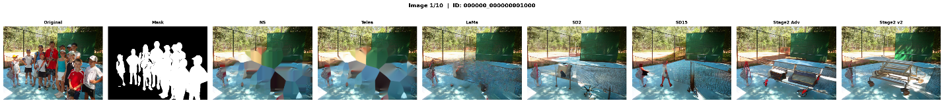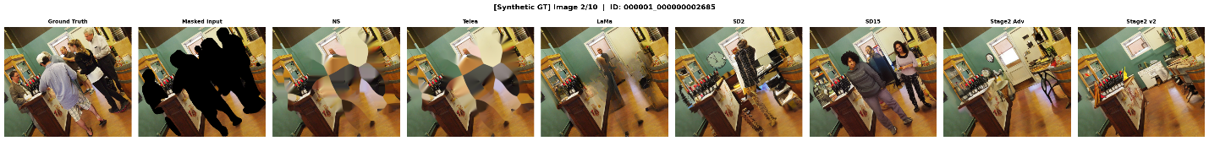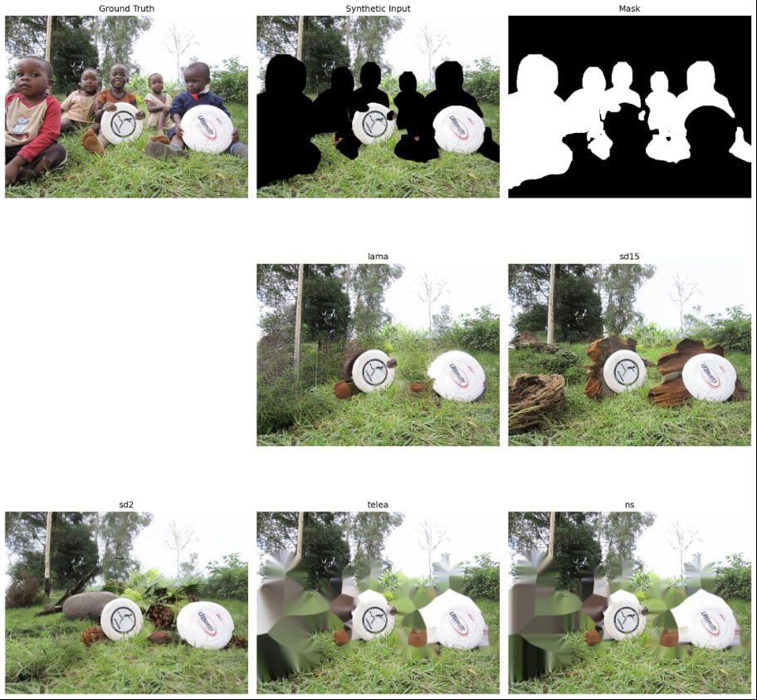
Figure 6: Baseline comparison visual grid: shows outputs from Navier–Stokes, Telea, LaMa, Stable Diffusion, and hybrid methods for the same input image
.

4.3 Progressive Removal Analysis
One of the key observations during the development of the system was that single-shot removal becomes less reliable when the combined mask region is large. In this experiment, Method A represents the single-shot removal strategy, where all detected person masks are merged into one combined mask and removed in a single inpainting pass. Method B represents the progressive instance-wise removal strategy, where detected persons are removed sequentially, starting from the largest detected instance. This progressive design was explored to reduce the difficulty of reconstructing very large masked regions at once.
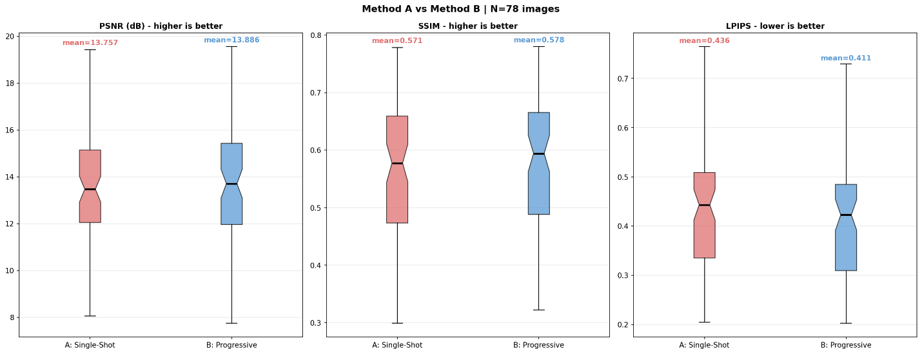
Figure 7: Metric comparison between Method A single-shot removal and Method B progressive instance-wise removal using PSNR, SSIM, and LPIPS.

As shown in Figure 4.2, Method B produced slightly better average PSNR and SSIM values than Method A. The average PSNR improved from 13.757 dB to 13.886 dB, while SSIM increased from 0.571 to 0.578. Although these improvements are small, the LPIPS score improved more noticeably from 0.436 to 0.411, indicating better perceptual similarity and more visually realistic reconstruction.

Table III: Quantitative comparison between single-shot removal and progressive instance-wise removal.
Method | Strategy | Samples | PSNR ↑ | SSIM ↑ | LPIPS ↓ | Time (s) ↓
Method A | Single-shot removal | 78 | 13.757 | 0.571 | 0.436 | 0.196
Method B | Progressive instance-wise removal | 78 | 13.886 | 0.578 | 0.411 | 1.084

The per-image win-rate analysis in Figure 4.3 further supports this finding. Method B outperformed Method A in 42 out of 78 images for PSNR, 58 out of 78 images for SSIM, and 72 out of 78 images for LPIPS. This means the progressive method achieved a 92.3% win rate based on LPIPS, showing that it was more effective in improving perceptual quality. However, this improvement comes with increased computational cost because progressive removal requires multiple inpainting passes for each image.

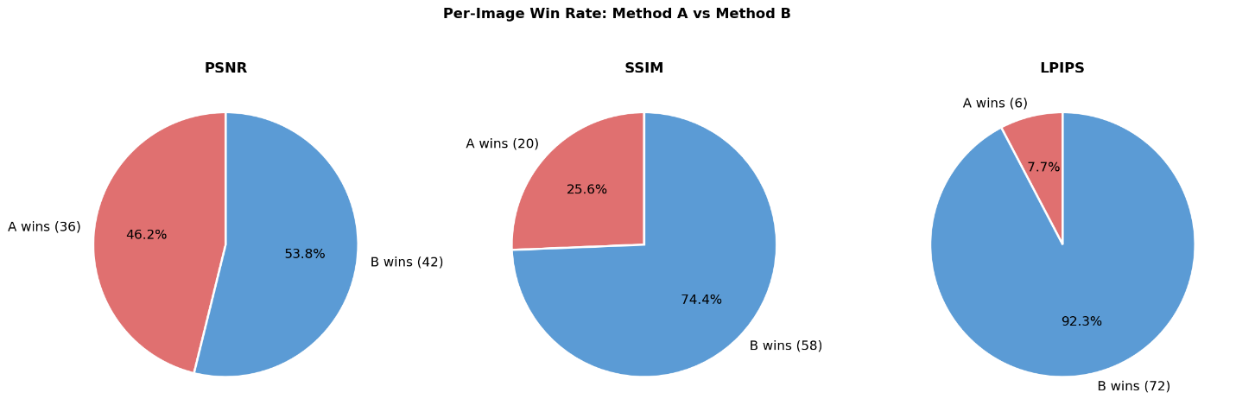

Figure 8: Per-image win-rate comparison between Method A and Method B across PSNR, SSIM, and LPIPS.

4.4 Multi-Method Comparison and Trade-off Analysis
In the next stage of experimentation, multiple variants of the pipeline were evaluated to analyze the trade-off between reconstruction quality and object removal effectiveness. Four methods were compared in this study. Method A represents single-shot global removal, where all detected person masks are combined and removed in one inpainting step. Method B represents progressive global removal, where detected persons are removed sequentially instead of all at once. Method C represents progressive local crop-based removal, where local regions around the detected persons are processed to preserve more background structure. Method D represents hybrid global removal with residual refinement, where remaining person-like regions are detected again and refined to reduce residual object presence.
The results indicate a clear trade-off between visual reconstruction quality and object removal strength. Method C achieved the highest reconstruction quality, with PSNR around 13.96, SSIM around 0.583, and LPIPS around 0.387. This suggests that local crop-based refinement preserved background structure and perceptual quality more effectively than the other variants. However, Method C did not remove all person instances completely, showing that high visual quality does not always guarantee complete object removal.

Table IV: Multi-method comparison showing the trade-off between reconstruction quality and residual object removal.
Method | Strategy | PSNR ↑ | SSIM ↑ | LPIPS ↓ | OUT-SSIM ↑ | Remaining Persons ↓ | Time (s) ↓
Method A | Single-shot global removal | 13.355 | 0.453 | 0.434 | 0.545 | 3.130 | 0.167
Method B | Progressive global removal | 12.794 | 0.397 | 0.492 | 0.476 | 4.385 | 1.047
Method C | Progressive local crop-based removal | 13.963 | 0.583 | 0.387 | 0.687 | 4.125 | 0.382
Method D | Hybrid residual refinement | 12.736 | 0.398 | 0.546 | 0.475 | 0.010 | 0.958

In contrast, Method D achieved the strongest residual removal performance, with the average remaining person count reduced close to zero. This shows that residual refinement was effective in suppressing detectable person-like regions. However, Method D produced lower reconstruction quality compared to Method C, indicating that aggressive residual removal can degrade visual realism and structural consistency.
Figure 4.4 presents the quantitative comparison of Methods A–D across reconstruction and residual-removal metrics, while Figure 4.5 further analyzes the effect of mask area coverage and number of persons on performance. These findings show that object removal requires balancing two competing goals: producing visually realistic reconstructed backgrounds and fully suppressing the removed object. A method may achieve strong PSNR, SSIM, or LPIPS values while still leaving detectable object traces, whereas a method that strongly removes residual objects may introduce more visual artifacts.

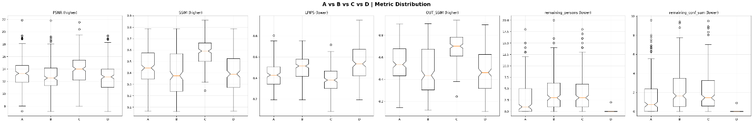
Figure 9: Per-image performance comparison of Methods A–D across PSNR, SSIM, LPIPS, and residual detection metrics, highlighting the trade-off between reconstruction quality and object removal effectiveness.

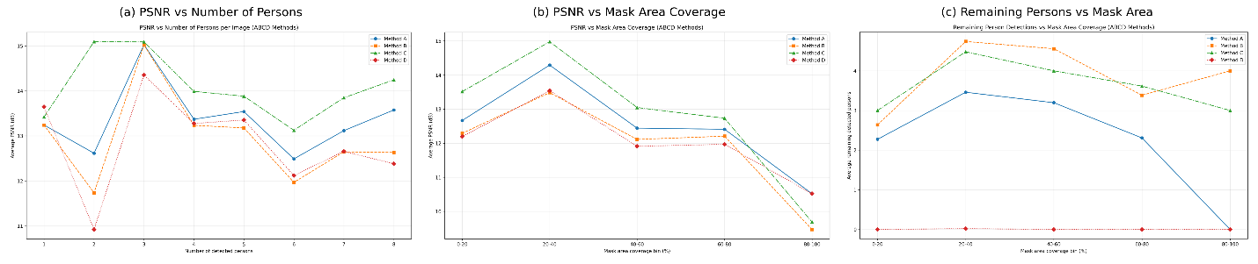

Figure 10: Trade-off analysis of reconstruction quality and object removal effectiveness under increasing scene complexity.
(a) PSNR decreases as mask area coverage increases, highlighting the difficulty of reconstructing large missing regions.
(b) Remaining detected persons decrease significantly for the hybrid method, demonstrating superior object removal capability.
(c) PSNR variation with the number of persons indicates performance degradation in crowded scenes.

4.5 Stage-wise Development of the Final Pipeline
Following the multi-method comparison and trade-off analysis, the experimental findings were consolidated into a structured and reproducible pipeline. Instead of treating detection, masking, and reconstruction as separate experiments, the system was organized into a sequence of well-defined stages to ensure consistency, stability, and scalability.
The development began with a unified data preparation stage, where a subset of 200 images containing multiple person instances was selected from a COCO-style dataset. Each image was processed using YOLOv8x-seg to detect person instances and generate corresponding segmentation masks. This ensured that all images were paired with consistent instance-level mask information, forming the basis for subsequent processing and evaluation.
To improve data quality and reliability, a filtering stage was introduced. Automatically generated masks were evaluated based on their coverage and structure, and images with extremely small, excessively large, or noisy masks were removed. This resulted in a refined dataset of 104 samples. The dataset was then organized into structured splits for controlled experimentation, enabling consistent comparison across different pipeline configurations.
The core pipeline was established through a multi-stage design integrating detection, mask refinement, global reconstruction, and local refinement. After detection, raw masks were processed using morphological operations to remove noise, fill gaps, and improve boundary quality. Additional smoothing and feathering techniques were applied to reduce sharp transitions, while a context ring was generated around the masked region to preserve surrounding structural information.
The reconstruction stage follows a hybrid global–local strategy. A global inpainting model (LaMa) is first applied to reconstruct the overall structure of the scene, ensuring spatial consistency across the image. However, since global reconstruction alone may produce smooth or less detailed textures, a second stage performs local refinement using a diffusion-based inpainting model (Stable Diffusion 2). This refinement is applied to cropped regions around the masked area, allowing the model to focus on improving fine details and perceptual realism. The refined region is then blended back into the full image using smooth transitions to avoid visible artifacts.
To further enhance stability and output quality, additional refinements were incorporated into the pipeline. Mask boundaries were handled more consistently to reduce edge artifacts, and blending operations were improved to ensure seamless integration between reconstructed and original regions. The execution flow was also stabilized to handle complex cases such as overlapping masks and large removal regions, resulting in more reliable outputs across diverse scenes.
An additional refinement stage was explored using a lightweight learning-based model. This approach attempted to learn residual corrections on top of the reconstructed outputs using a compact U-Net architecture trained on synthetically generated data. While this method showed limited improvements in certain cases, it did not consistently outperform the hybrid reconstruction pipeline. Therefore, it was not included in the final system but remains a potential direction for future improvement.
Overall, this stage-wise development transformed the system into a cohesive framework that integrates instance-aware detection, refined mask generation, global structural reconstruction, and local diffusion-based enhancement. This structured design provides a stable and scalable foundation for the final evaluation presented in the next section.
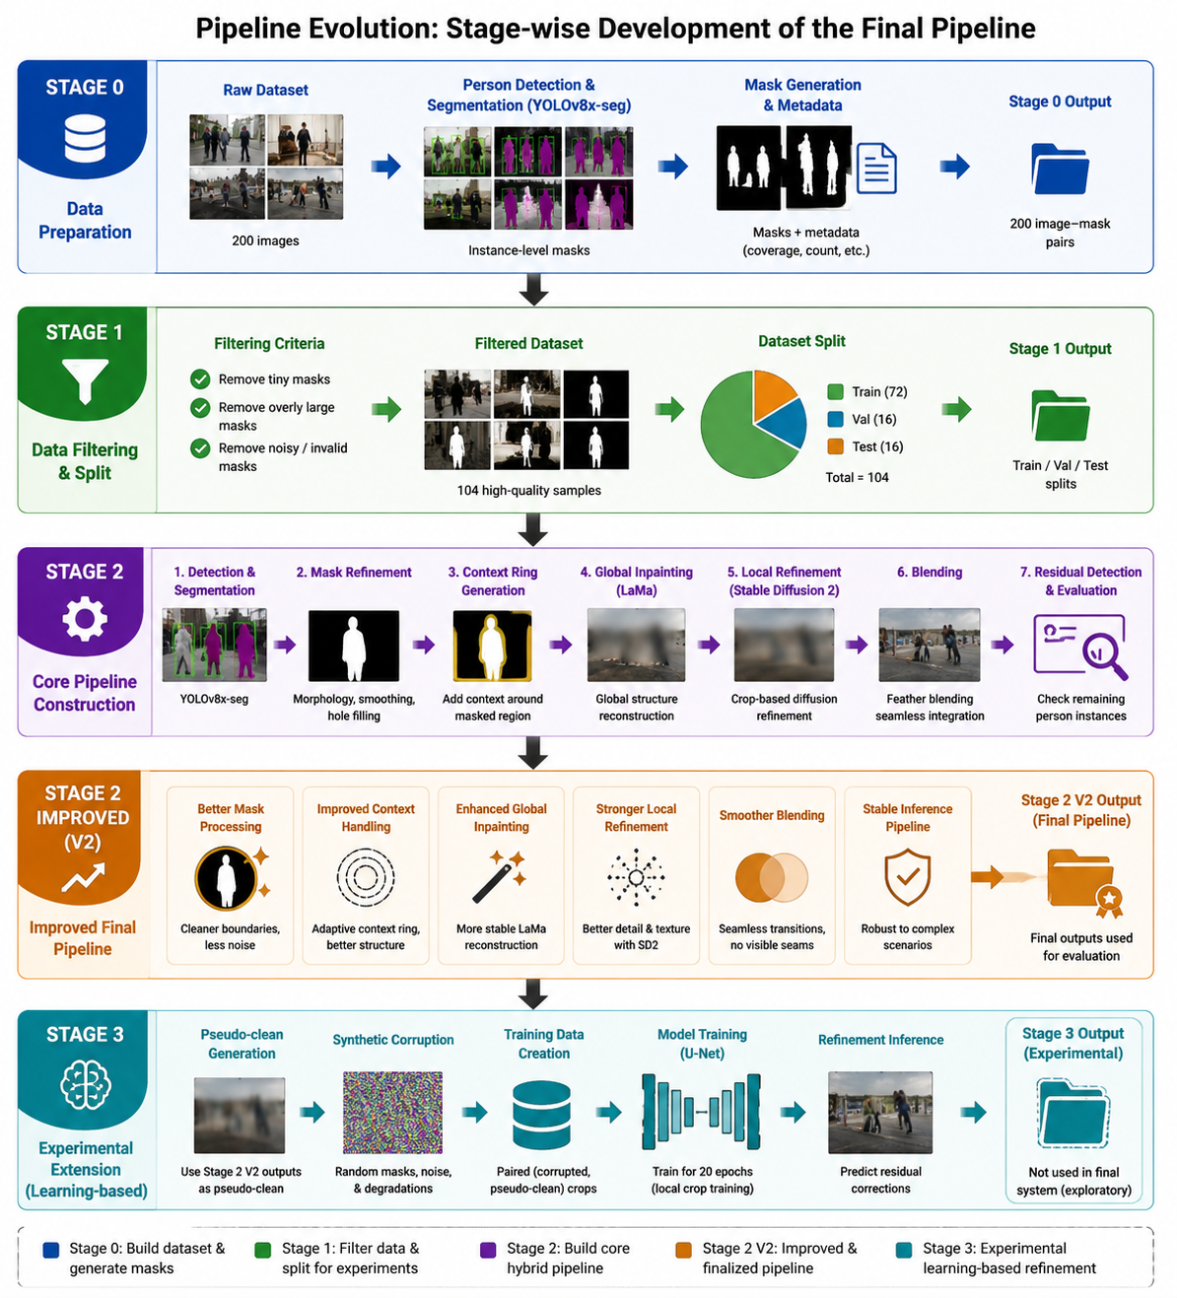
Figure 11: Stage-wise evolution of the proposed instance-aware object removal pipeline. The system progresses from initial data preparation and filtering to a hybrid global–local reconstruction framework. The improved Stage 2 (V2) represents the finalized pipeline used for evaluation, while Stage 3 illustrates an experimental learning-based refinement extension.

4.6 Final Proposed Method Evaluation
The final proposed method corresponds to the improved Stage 2 V2 pipeline, which integrates the major refinements developed throughout the project. This pipeline combines refined mask processing, context-aware cropping, LaMa-based global reconstruction, Stable Diffusion 2-based local refinement, smooth blending, and second-pass refinement. The method was evaluated on the filtered dataset of 104 valid multi-person images.
The quantitative results show that the final pipeline achieved an average PSNR of approximately 18.17, SSIM of 0.713, and OUT-SSIM of 0.774. These values indicate that the proposed method was able to reconstruct masked regions with reasonable structural quality while preserving the non-masked areas effectively. Compared with earlier experiments, the final pipeline produced more stable and visually coherent reconstructions, especially in cases where the removed region had moderate mask coverage.
Table V: Final performance summary of the proposed Stage 2 V2 pipeline on evaluated samples.
Metric | Value
Evaluated samples | 104
Final mask area ratio | 0.160
PSNR region ↑ | 18.170
SSIM region ↑ | 0.713
OUT-SSIM ↑ | 0.774
LPIPS full ↓ | 0.000062
Residual count ↓ | 6.962
Residual max confidence | 0.916
LaMa global time | 0.924 s
Local diffusion time | 7.013 s
Total time | 7.937 s

However, residual detection analysis shows that complete object removal remains challenging. The average residual detection count was approximately 6.96, with high residual confidence in some samples. This indicates that even when the reconstructed image appears visually smooth, the detector may still identify person-like structures or remaining human features. This finding supports the need for residual-aware evaluation in object removal tasks, because traditional reconstruction metrics alone cannot fully measure removal effectiveness.
The computational analysis also shows a clear trade-off between reconstruction quality and processing time. The LaMa global inpainting stage required approximately 0.92 seconds per image, while the Stable Diffusion 2 local refinement stage required approximately 7.01 seconds per image. The total average processing time was approximately 7.94 seconds per image. Therefore, the final method improves reconstruction quality but requires higher computational cost compared with classical inpainting methods.
Figure 12 presents qualitative examples from the final proposed pipeline. The success cases show that the hybrid global–local strategy can reconstruct visually coherent backgrounds after person removal. The failure cases show remaining artifacts, blurry regions, or detectable person-like structures, especially in crowded scenes or large-mask cases. These examples confirm the main finding of the project: the proposed method improves reconstruction quality, but complete semantic removal in complex multi-person scenes remains an open challenge.
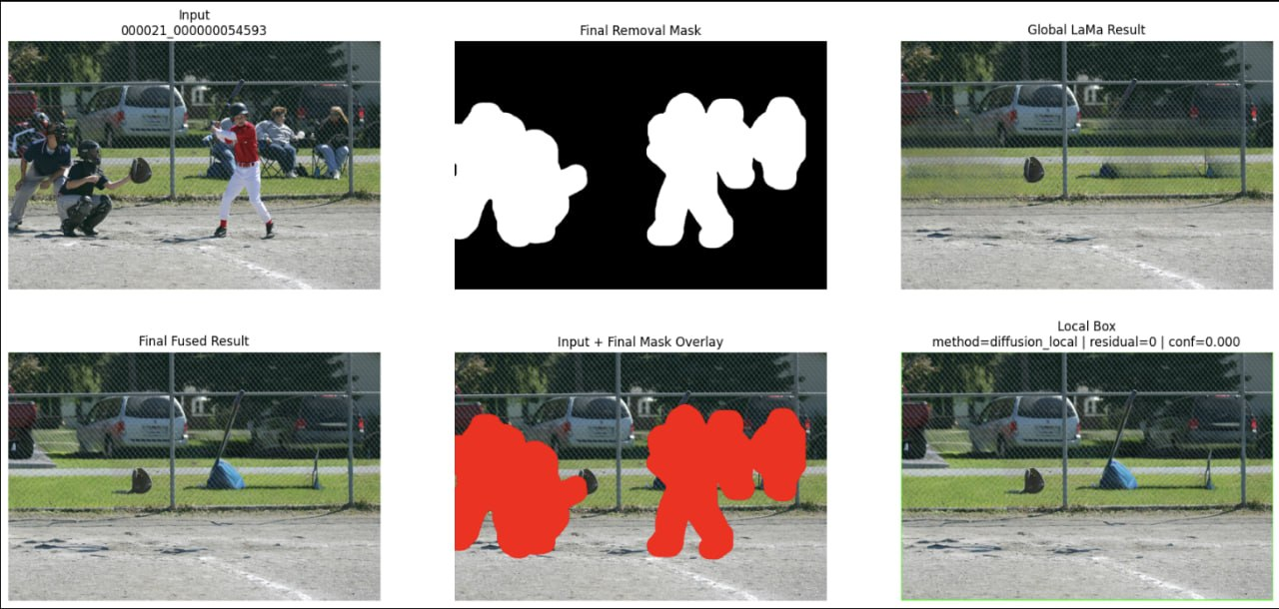
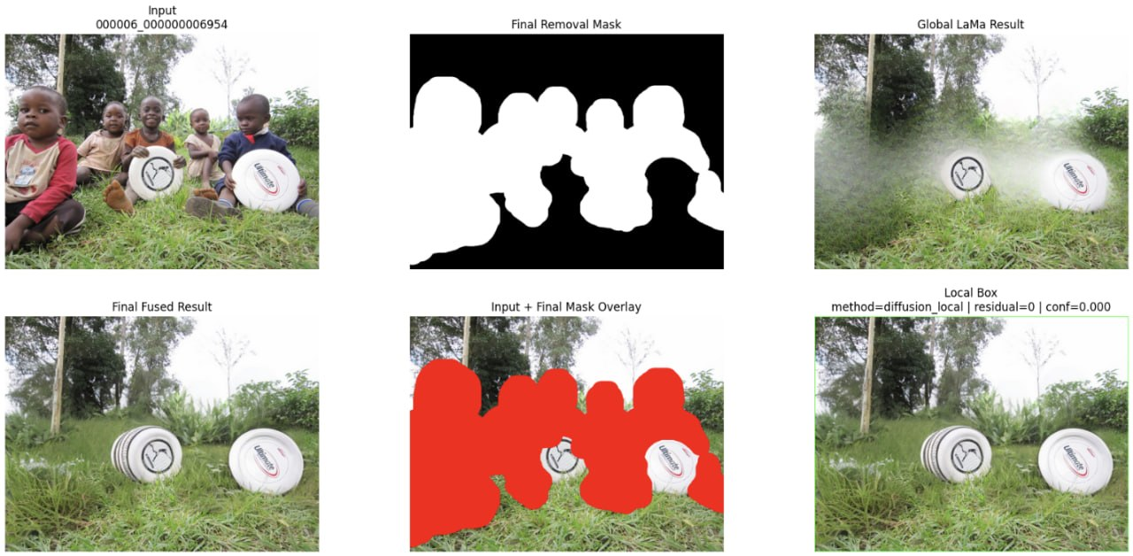
Figure 12: Qualitative results of the final proposed pipeline. Each row shows the input image, detection or mask information, and reconstructed output. The success cases demonstrate visually coherent background reconstruction.

4.7 Discussion
The experimental results show that the proposed multi-stage framework improves reconstruction quality compared to earlier single-step approaches. The combination of LaMa-based global inpainting and Stable Diffusion 2-based local refinement allows the system to maintain overall structural consistency while improving local texture and perceptual realism. The progressive, multi-method, and stage-wise experiments also show that object removal performance depends strongly on mask size, scene complexity, and the balance between reconstruction quality and residual suppression.
A major finding of this work is that higher visual quality does not always guarantee complete object removal. Method C produced stronger reconstruction metrics in the multi-method comparison, but residual person-like structures were still present in many cases. In contrast, Method D reduced residual detections more effectively, but aggressive refinement lowered visual quality. This confirms that object removal should be evaluated using both reconstruction metrics and residual detection metrics.
The final Stage 2 V2 pipeline achieved better stability and reconstruction quality than earlier experimental versions, but several limitations remain. The system still struggles in highly crowded scenes, large-mask regions, and cases where people overlap heavily with complex backgrounds. The diffusion-based refinement stage also increases computational cost, making the final method slower than classical inpainting methods. In addition, the output quality depends strongly on detection and mask accuracy; poor masks can cause remaining object boundaries, halo artifacts, or unnecessary background removal.
Overall, the proposed framework provides a complete and realistic approach to instance-aware object removal by combining detection, refined mask generation, hybrid global–local reconstruction, and residual-aware evaluation. The results demonstrate that the method is effective for improving background reconstruction quality, while also revealing that complete semantic object removal in complex real-world scenes remains a challenging open problem.

Chapter 5 Conclusions

5.1 Summary
This research presented an instance-aware object removal and high-fidelity background reconstruction framework for complex multi-person images. The main purpose of the project was to move beyond simple single-step inpainting and design a structured pipeline that can detect human instances, generate removal masks, refine mask boundaries, reconstruct missing background regions, and evaluate whether the removed persons still remain detectable after reconstruction.
The final proposed system followed a multi-stage hybrid design. First, person instances were detected and segmented using YOLOv8x-seg. The generated masks were then refined through morphological cleaning, dilation, smoothing, feathering, and context-aware processing. After that, LaMa was used for global background reconstruction because of its strong ability to preserve scene structure. Stable Diffusion 2 was then applied as a local refinement model to improve visual realism and texture quality in the reconstructed regions. Finally, residual detection was performed using YOLOv8x-seg to analyze whether person-like structures remained in the final output.
The experiments showed several important insights. Classical methods such as Telea and Navier–Stokes were fast and produced reasonable structural results for smaller masks, but they were not reliable for complex semantic reconstruction. LaMa produced stronger global reconstruction and better perceptual quality, but sometimes generated smooth textures. Stable Diffusion was useful for local visual refinement, but applying it directly to large masks could lead to unstable or unrealistic outputs. The hybrid strategy was therefore more effective because it combined LaMa’s structural stability with diffusion-based local enhancement.
The final evaluated pipeline achieved an average PSNR of approximately 18.17, SSIM of 0.713, and OUT-SSIM of 0.774 on the processed dataset. These results indicate that the proposed method was able to reconstruct masked regions with reasonable quality while preserving non-masked regions effectively. However, residual detection analysis showed that complete person removal remained difficult, with an average residual detection count of 6.96. This result is important because it shows that visual reconstruction quality alone is not enough for evaluating object removal. A generated image may look smooth but still contain person-like structures detectable by a strong object detector.
Overall, this project demonstrated that a multi-stage hybrid inpainting framework is a promising direction for real-world object removal. The main contribution of the work is not only the final output quality, but also the complete methodology: instance-aware detection, refined mask generation, global-local reconstruction, second-pass refinement, and residual-aware evaluation. This makes the proposed system more complete and research-oriented than a simple image inpainting experiment.

5.2 Limitations
Although the proposed framework achieved meaningful reconstruction results, several limitations remain. The first major limitation is the absence of true clean ground-truth background images. Since the dataset contains real-world COCO images, the actual background behind the removed persons is unknown. Therefore, evaluation had to rely on proxy metrics, synthetic comparisons, masked-region metrics, and residual detection. This makes the evaluation realistic but not perfectly equivalent to paired ground-truth reconstruction.
The second limitation is the remaining residual person detection. Even after applying the final hybrid pipeline, the detector still identified person-like structures in many reconstructed images. This may happen because some reconstructed regions preserve human-shaped textures, because surrounding people remain outside the target mask, or because the detector is sensitive to partial body-like patterns. Therefore, the residual count should be interpreted carefully, but it still indicates that complete semantic object removal is a difficult problem.
The third limitation is computational cost. Classical methods can run very quickly, while the final hybrid pipeline requires both LaMa and diffusion-based local refinement. In the final evaluation, LaMa required about 0.92 seconds per image, while diffusion-based local refinement required about 7.01 seconds per image, resulting in an average total processing time of about 7.94 seconds per image. This makes the method suitable for research-quality reconstruction, but less suitable for real-time applications without further optimization.
The fourth limitation is mask sensitivity. The final output depends heavily on the quality of the detected segmentation mask. If the mask is too small, parts of the person may remain visible. If the mask is too large, important background context may be removed, making reconstruction harder. Although mask refinement improved boundary quality, challenging cases with occlusion, overlapping people, or crowded scenes still remained difficult.
The fifth limitation is that diffusion-based refinement is not always stable. Stable Diffusion can improve local texture and realism, but it may also introduce hallucinated content when the input crop contains limited context or when the masked area is too large. This confirms one of the main findings of the project: diffusion models are powerful but must be applied carefully in object removal tasks.

5.3 Future Improvement
Future work can improve the proposed system in several directions. First, the evaluation can be strengthened by constructing a paired synthetic dataset where clean background images are available. In such a dataset, objects can be artificially inserted and then removed, allowing direct comparison between reconstructed output and ground-truth background. This would make PSNR, SSIM, and LPIPS evaluation more reliable.
Second, the residual removal stage can be improved by designing a detector-guided refinement loop. In this approach, the reconstructed image would be passed through a person detector, and any remaining person-like regions would be automatically re-masked and refined again. This could reduce the residual detection count and improve actual object removal effectiveness.
Third, the mask generation process can be improved using stronger segmentation models or ensemble segmentation. Combining YOLOv8x-seg with SAM could produce more precise masks, especially around difficult boundaries such as hair, clothing edges, hands, and overlapping people. Better masks would directly improve reconstruction quality and reduce halo artifacts.
Fourth, the diffusion refinement stage can be made more controllable. Instead of applying generic diffusion inpainting, future work can use object-removal-specific prompts, ControlNet-based structural guidance, or depth-aware conditioning to preserve background geometry. This could reduce hallucination and improve consistency in complex scenes.
Fifth, a learning-based local refinement model can be further explored using stronger training data. In this project, a lightweight U-Net refinement model was tested using pseudo-clean targets, but it mainly acted as a smoothing model and did not improve fine details enough. With paired ground-truth data and better loss functions, such as perceptual loss, adversarial loss, and boundary-aware loss, a trainable refinement model could become more effective.
Finally, the system can be optimized for speed and deployment. Model quantization, smaller diffusion models, faster samplers, and GPU-efficient batching could reduce inference time. This would make the framework more practical for real-world image editing applications.
In conclusion, this research successfully developed and evaluated a complete instance-aware object removal framework for complex multi-person scenes. The project showed that hybrid global-local inpainting can improve reconstruction quality, but also revealed that true object removal requires evaluation beyond visual similarity metrics. The proposed system provides a strong foundation for future research in realistic object removal, background reconstruction, and image editing systems.

References
[1] J. Redmon, S. Divvala, R. Girshick and A. Farhadi,
"You Only Look Once: Unified, Real-Time Object Detection,"
in Proceedings of the IEEE Conference on Computer Vision and Pattern Recognition (CVPR), 2016, pp. 779–788.

[2] A. Kirillov et al.,
"Segment Anything,"
in Proceedings of the IEEE International Conference on Computer Vision (ICCV), 2023.

[3] R. Suvorov et al.,
"Resolution-robust Large Mask Inpainting with Fourier Convolutions,"
in Proceedings of the IEEE/CVF Conference on Computer Vision and Pattern Recognition (CVPR), 2022.

[4] R. Rombach et al.,
"High-Resolution Image Synthesis with Latent Diffusion Models,"
in Proceedings of the IEEE/CVF Conference on Computer Vision and Pattern Recognition (CVPR), 2022.

[5] A. Lugmayr et al.,
"RePaint: Inpainting using Denoising Diffusion Probabilistic Models,"
in Proceedings of the IEEE/CVF Conference on Computer Vision and Pattern Recognition (CVPR), 2022.

[6] M. Bertalmio, A. L. Bertozzi and G. Sapiro,
"Navier-Stokes, Fluid Dynamics, and Image and Video Inpainting,"
in Proceedings of the IEEE Conference on Computer Vision and Pattern Recognition (CVPR), 2001.

[7] A. Telea,
"An Image Inpainting Technique Based on the Fast Marching Method,"
Journal of Graphics Tools, vol. 9, no. 1, pp. 23–34, 2004.

[8] D. Pathak, P. Krähenbühl, J. Donahue, T. Darrell and A. A. Efros,
"Context Encoders: Feature Learning by Inpainting,"
in Proceedings of the IEEE Conference on Computer Vision and Pattern Recognition (CVPR), 2016.

[9] J. Yu et al.,
"Free-Form Image Inpainting with Gated Convolution,"
in Proceedings of the IEEE International Conference on Computer Vision (ICCV), 2019.

